LAB RECORD UNIT 1
1.Create +C46:C65a basic HTML web page using headings, paragraphs, and text formatting tags.

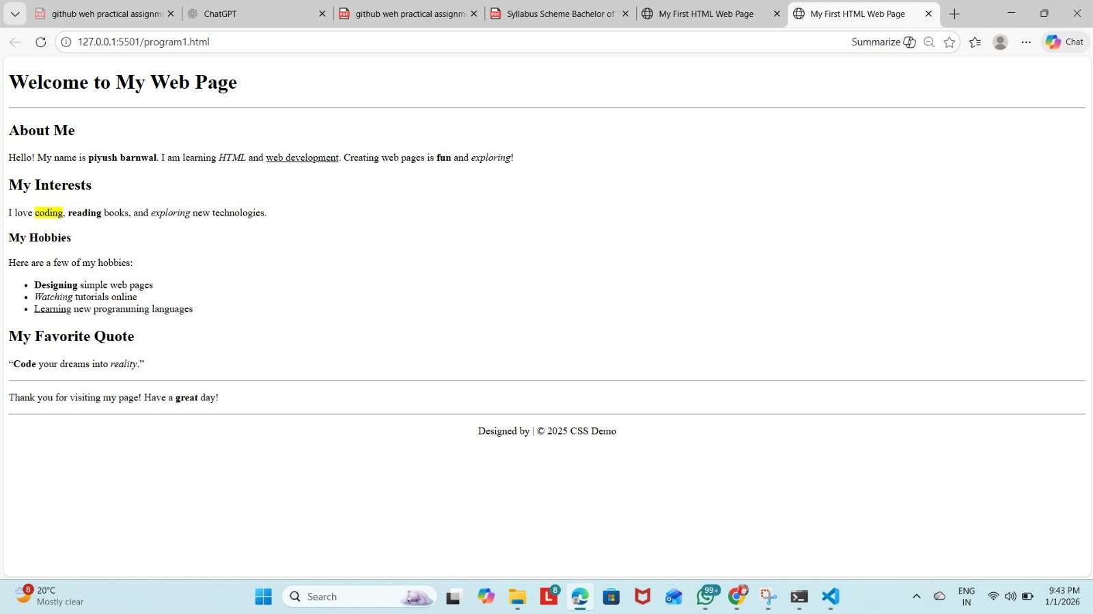

- Design a webpage demonstrating HTML links, images, and lists (ordered, unordered, nested)

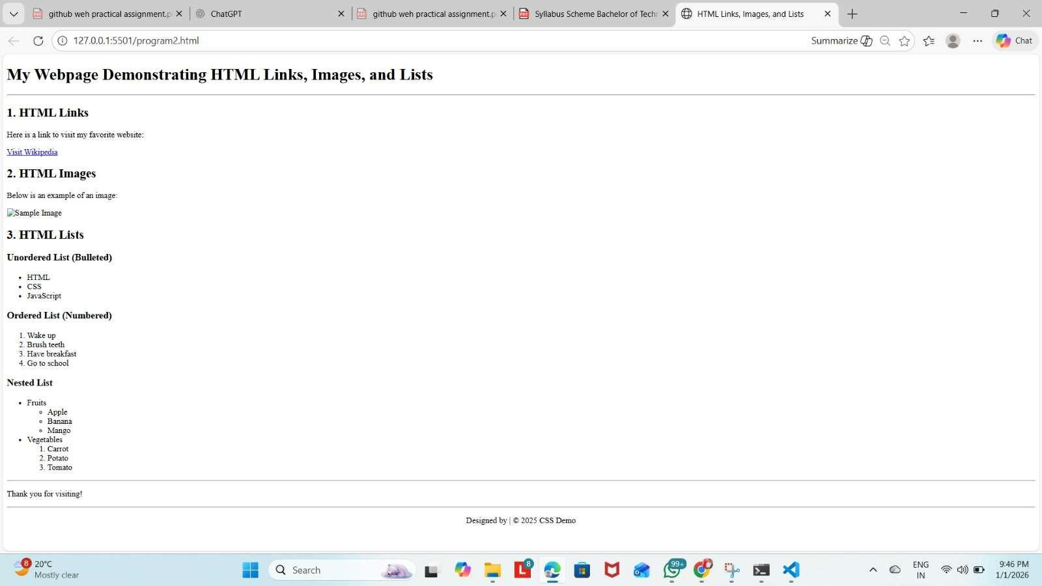

- Create a table-based layout with merged cells, alignment, and caption using HTML



- Design a webpage with an HTML form having text input, radio buttons, checkboxes, select menus, and
submit/reset buttons

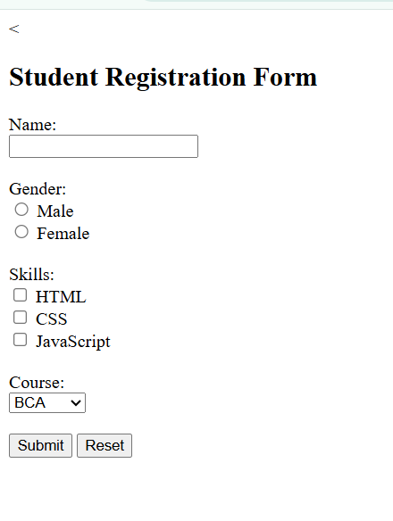

- Use semantic elements (<article>, <section>, <nav>,
<aside>, <footer>) to build a structured web page.

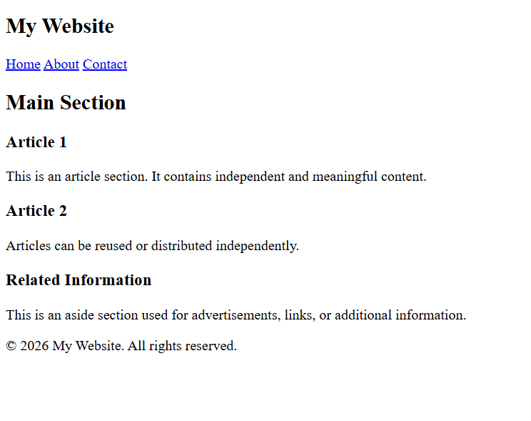

LAB RECORD UNIT 2
- Apply Inline, Internal, and External CSS styles to HTML elements.

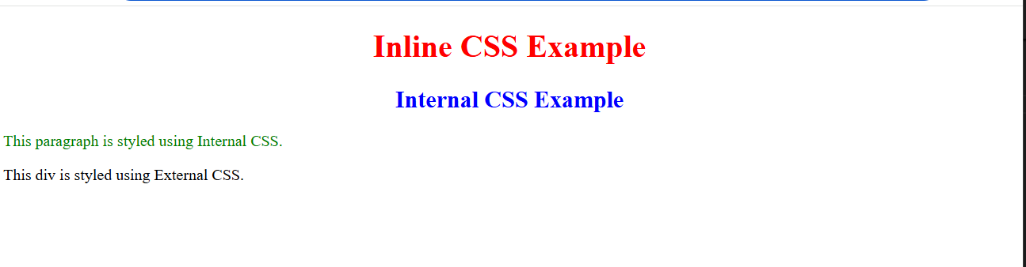

- Style a web page using advanced CSS: Box Model, background images, borders, margins, and padding

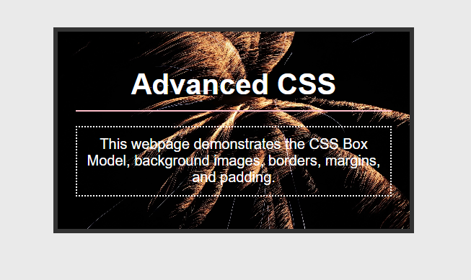

- Demonstrate the use of different CSS selectors (class, id, descendant, group, universal)

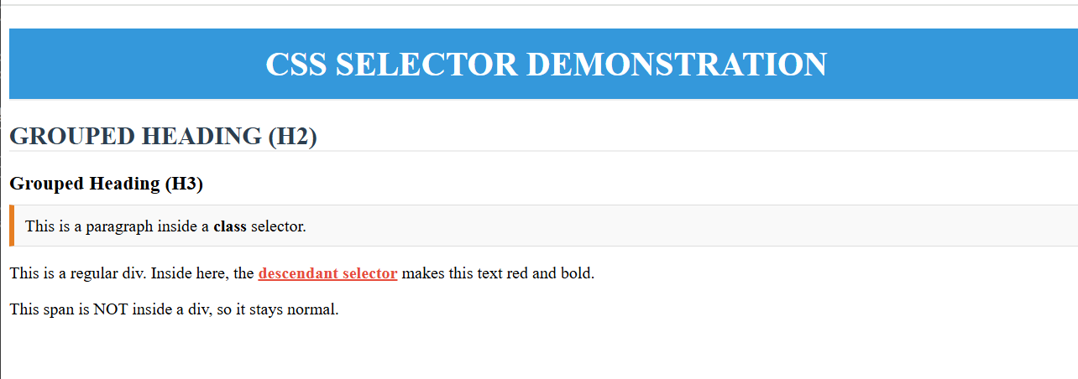

- Create a responsive web page using media queries and mobile-first design with flexible units

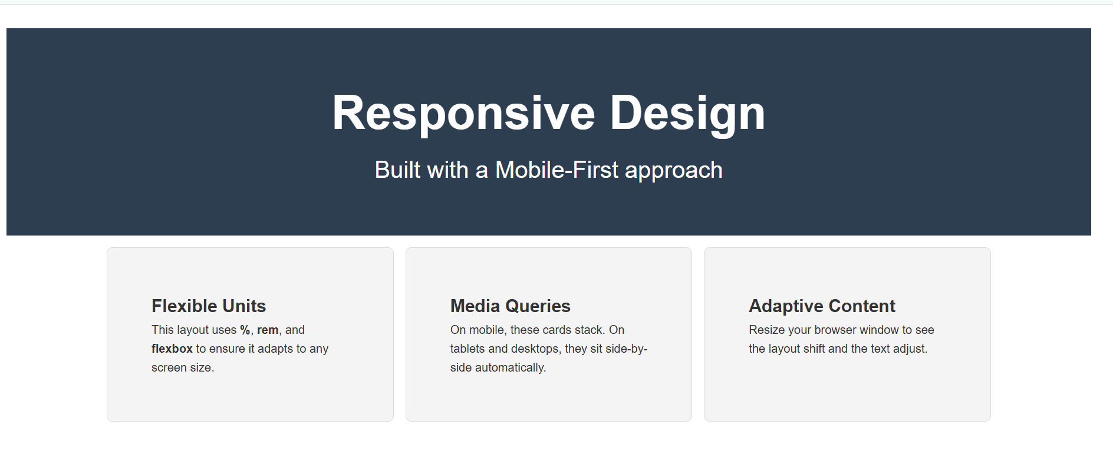

- Use div and span elements for layout and apply styling with CSS

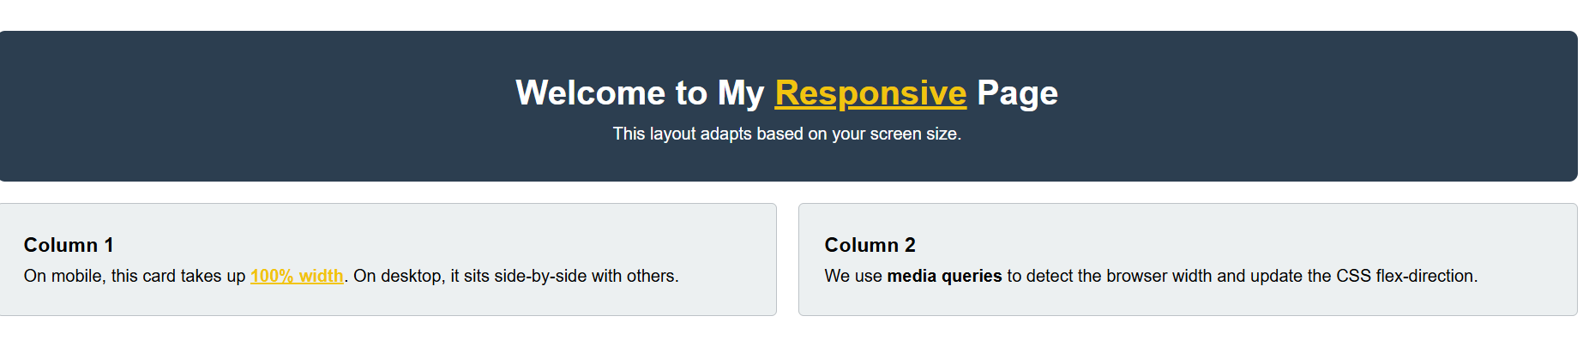

LAB RECORD UNIT 3
  - Create a JavaScript-enabled web page that performs basic arithmetic operations using input from users
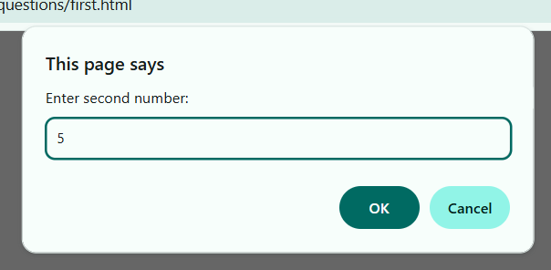
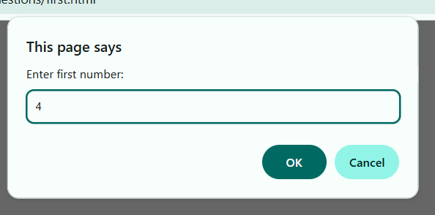

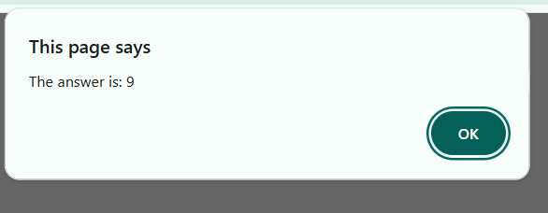
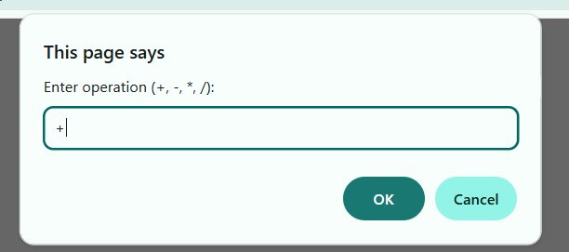
  - Write JavaScript to demonstrate conditional statements and looping (for, while, do…while)

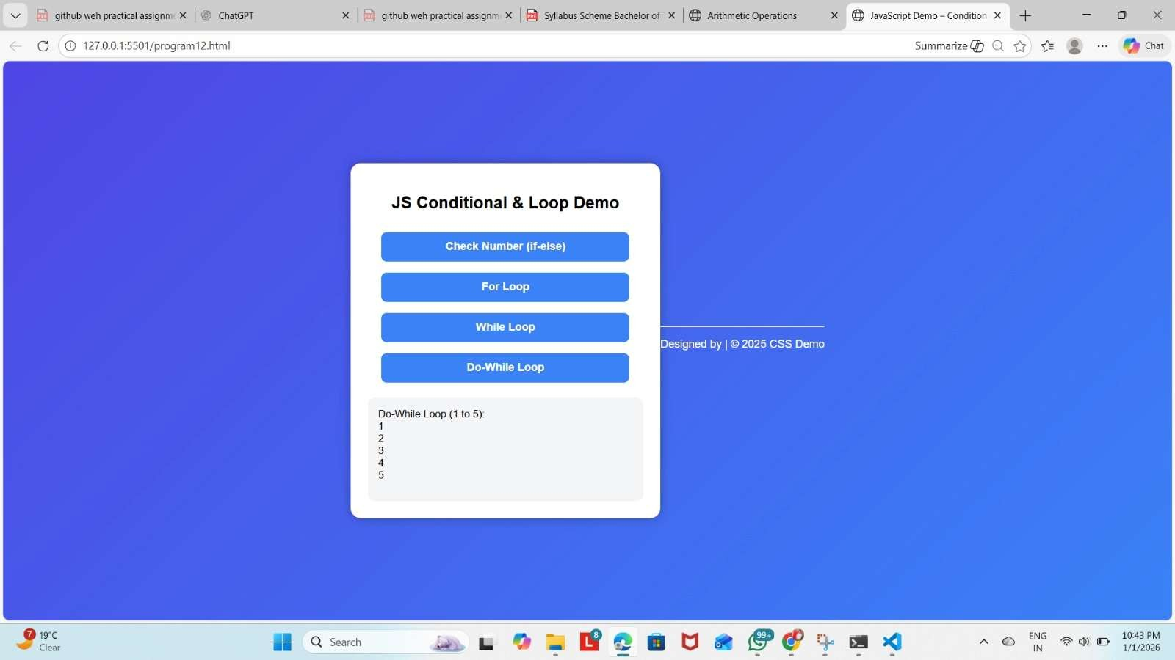

  - Create and invoke user-defined functions in JavaScript; use var, let, and const for scope demonstration
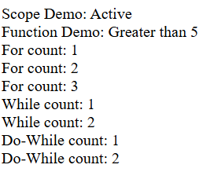

  - Handle HTML form validation using JavaScript events like on submit, on input, and use alert() for feedback.

LAB RECORD UNIT 4

    - Demonstrate DOM manipulation using getElementById(), querySelector(), and innerHTML.

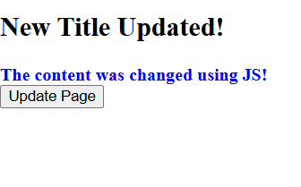
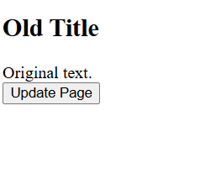

    - Show or hide HTML elements using JavaScript and toggle CSS classes dynamically

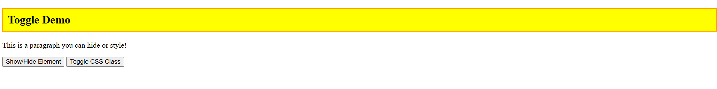

    - Add interactivity using event listeners (addEventListener, removeEventListener) for mouse/keyboard events.

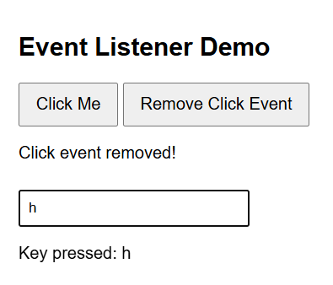

    - Create and manipulate elements using JavaScript: append, remove, or modify child nodes.

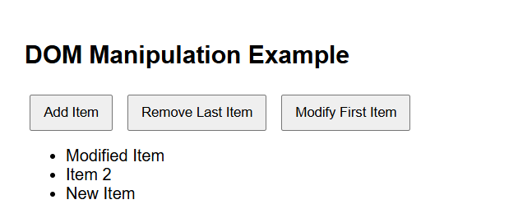

  - Create a simple drawing using the <canvas> element: draw shapes and fill colors.

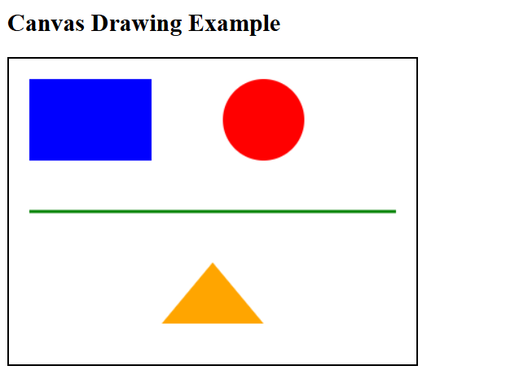
LAB RECORD UNIT 5

20. Initialize a Git repository, commit changes, and push to GitHub; Deploy a personal portfolio site on
GitHub Pages or Netlify.

Initializing a Git Repository, Pushing to GitHub, and Deploying a Personal Portfolio Website
Git and GitHub are widely used tools for version control and code hosting, while platforms like GitHub Pages and Netlify are used to deploy static websites. This process is commonly used to publish personal portfolio websites online.

Part A: Initialize a Git Repository and Commit Changes Step 1: Create a Project Folder
Create a folder for your personal portfolio website containing files such as:

index.html style.css

script.js (optional)

Step 2: Open Terminal / Command Prompt Open the terminal inside the project folder.

Step 3: Initialize Git Repository bash
Copy code git init
−–踰踳 This command initializes an empty Git repository.

Step 4: Check Repository Status bash
Copy code git status
−踳–踰 Shows untracked or modified files.

Step 5: Add Files to Staging Area bash
Copy code git add .
踰–−踳 Adds all project files to the staging area.

Step 6: Commit Changes bash
Copy code
git commit -m "Initial commit of portfolio website"
踰踳–− Saves changes with a meaningful message.

Part B: Push Project to GitHub Step 7: Create a Repository on GitHub
Log in to GitHub Click New Repository
Enter repository name (e.g., portfolio-website) Click Create Repository
Step 8: Connect Local Repository to GitHub bash
Copy code
git remote add origin https://github.com/username/portfolio-website.git

Step 9: Push Code to GitHub bash
Copy code
git branch -M main git push -u origin main
−–踰踳 Project files are now uploaded to GitHub.

Part C: Deploy Portfolio Website Using GitHub Pages Step 10: Open Repository Settings
Go to GitHub repository Click Settings → Pages
Step 11: Enable GitHub Pages Select Branch: main

Select Folder: /root Click Save
Step 12: Access Live Website GitHub generates a URL like:

踳踰–− https://username.github.io/portfolio-website/

OR
Part D: Deploy Portfolio Website Using Netlify Step 10: Login to Netlify
Go to www.netlify.com and log in.

Step 11: Deploy Using Drag & Drop Click Add new site → Deploy manually

Drag and drop your project folder Wait for deployment
Step 12: Live Website URL Netlify provides a live URL like:
踰–−踳 https://your-site-name.netlify.app

Advantages of Using GitHub Pages / Netlify Free hosting for static websites

Easy and fast deployment

Automatic HTTPS Ideal for personal portfolios
Conclusion
By initializing a Git repository, committing changes, and pushing code to GitHub, developers can manage their projects efficiently. Using GitHub Pages or Netlify, a personal portfolio website can be deployed easily and accessed globally through a live URL.

